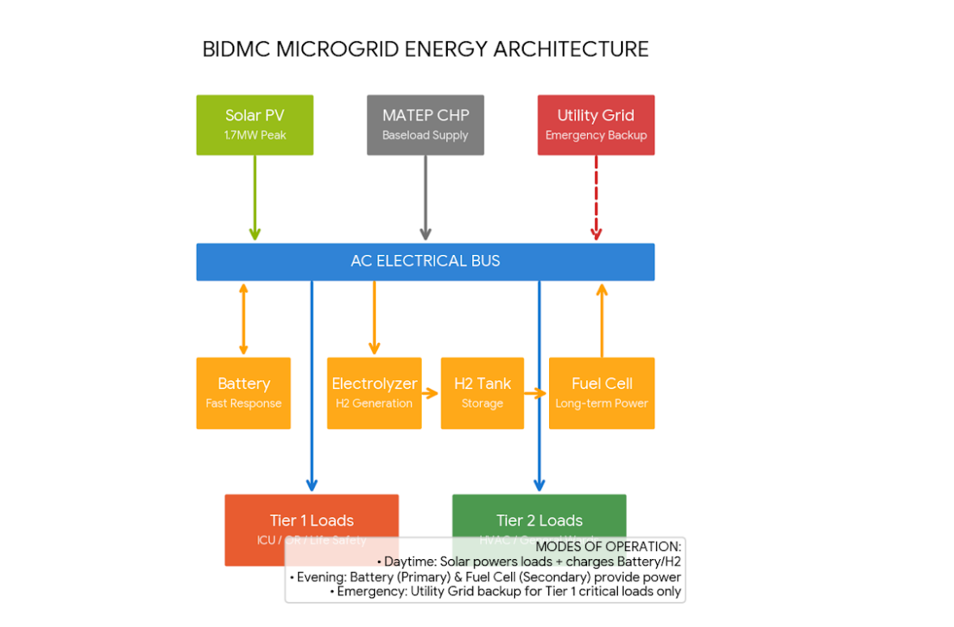
ENERGY FLOW AND SPECIFICATIONS FOR HYBRID HOSPITAL

Fig-1: Energy Flow Diagram
Priority | Source | Mode | PURPOSE
Level 1 | Solar PV | Sustainability | Normal daylight operations & storage charging.
Level 2 | Battery / H₂ | Resilience | After-hours operations and bridging short gaps.
Level 3 | MATEP CHP | Reliability | Constant baseload and thermal support.
Level 4 | Eversource Grid | Redundancy | Last-resort emergency backup for critical areas.

- Primary Generation (Daytime):
- Solar Lead: Solar energy is the main source.
- Direct Supply: Solar energy flows to the AC Electrical Bus (distribution point) to power the hospital immediately.
- The "Deposit": Any electricity not needed by the hospital is diverted to charge the Battery and run the Electrolyzer.

- Transition to Storage (Evening):
- Solar Fade: Solar production stops.
- The "Withdrawal": The Battery is the "first responder," discharging immediately to keep the bus powered. If the battery runs low, the Hydrogen Fuel Cell activates, converting the stored hydrogen back into electricity.
- Baseload Support: The MATEP CHP (Combined Heat and Power) plant provides a steady stream of natural gas-generated power to bridge any gaps.
- The Safety Net (Emergency):
- Grid Activation: The Eversource Grid stays on standby until a major failure occurs or on-site storage is depleted.
- Load Shedding: To protect the most critical patients, the system performs "Load Shedding." It pauses power to Tier 2 loads (HVAC, general wards, imaging) to ensure Tier 1 loads (ICU, Operating Rooms, and Life Safety) stay running indefinitely.

Critical Load Management
1. Critical Loads (Tier 1): What Should Not Go Down
These systems are defined as "never interrupted" and are the only loads guaranteed during an emergency grid backup scenario.
- Intensive Care Units (ICU): Continuous monitoring and life-support systems.
- Operating Rooms (OR): Surgical equipment and critical environment controls.
- Life Safety: Emergency lighting, fire systems, and critical communications.

2. Essential Loads (Tier 2): Shiftable/Interruptible
These are considered "essential" but may be "load " (paused) if on-site storage is depleted or during a grid emergency to prioritize Tier 1.
- HVAC: Building climate control.
- Imaging: Diagnostic machines like MRIs and CT scans.
- General Wards: Patient rooms and administrative areas.
Tier | Priority | Includes | Status in Emergency
Tier 1 | Critical | ICU, Operating Rooms (OR), Life Safety (Fire/Alarms), Critical Communications | Always On: Guaranteed by Battery, Fuel Cell, and Grid.
Tier 2 | Essential | Clinical HVAC, Imaging (MRI/CT), Medical Wards, Critical Lighting | Shiftable: May be curtailed or cycled to preserve storage.
Tier 3 | Non-Critical | Administrative Offices, Cafeteria, Gift Shop, Non-essential Lighting | Shed First: Paused immediately during a grid emergency.

Approximate Power Requirements (from the hospital_ communication csv for 5 min intervals):
- Tier 1 (Medical Equipment): Averages ~3.01 kWh per interval (approx. 36 kW). The baseline power required for patient monitoring and life-support machines that must never be interrupted.
- Tier 2 (HVAC & Clinical Support): Averages ~4.99 kWh per interval (approx. 60 kW). This is the largest single draw. While essential for patient comfort, the system is designed to "shift" these loads if the microgrid is running solely on backup storage.
- Tier 3 (Lighting & Admin): Averages ~2.00 kWh per interval (approx. 24 kW). This includes general lighting and non-clinical support. In "Energy Saving Mode," this is the first area where consumption is reduced.

Energy Balances & KPI’s:
- Overall Balance:
$$P_{solar}\left(t\right)+P_{CHP}\left(t\right)+P_{Grid}\left(t\right)+P_{Fuel Cell}\left(t\right)+P_{Battery discharge}\left(t\right)= P_{Load}\left(t\right)+P_{Battery Charging}\left(t\right)+P_{Electrolyzer}\left(t\right)$$
Where P_load is sum of all tiers (tier 1+2+3) and P_grid is typically zero unless there is an emergency.
- Component Balances:
  - Battery Storage System:
    - SoC update:
${SoC}_{(t)}= {SoC}_{\left(t-1\right)}+\left(\frac{P_{Battery charging\left(t\right)}×η_{charging}×∆t}{E_{cap}}\right)-\left(\frac{P_{Battery discharging\left(t\right)}×∆t}{E_{cap×}η_{discharging}}\right)$
Where $η_{}$ represents the round-trip efficiencies, $E_{cap}$ is the total amount of energy that the battery can store when it is fully charged (kWh). SoC(t) should remain between its min and max values.

  - Hydrogen Loop:

    - Electrolyzer (Charging): $m_{H2 produced}= \frac{P_{Electrolyzer}×∆t}{{LHV}_{H2}× η_{electrolyzer}}$
    - Fuel Cell (Discharging): $m_{H2 consumed}= \frac{P_{Fuel Cell}×∆t}{{LHV}_{H2}× η_{fuel cell}}$
    - Hydrogen Tank Balance: $Mass\left(t\right)=Mass\left(t-1\right)+m_{H2 produced}- m_{H2 consumed}$

Where ${LHV}_{H2}$ is the amount of heat released by combusting a specific amount of hydrogen. It is approximately 33.3 kWh/kg or 120MJ/kg for hydrogen
  - Load Tiers:

    - If P_available >= P _{Total Load} : All tiers are powered
    - If P_available< P_{Total Load}: Let go tier 3 (not critical)
    - If P_available < (Tier1 + Tier2): Let go tier 2
    - P_available must always be bigger than tier 1 in value as it is critical

  - KPI Formulae:

    - Self-Sufficiency Rate (SSR): $\frac{∑(P_{solar}+P_{CHP}+ P_{Fuel Cell+ }P_{Battery_discharge}}{∑P_{Load}} ×100$

    - Grid Dependency Ratio: $\frac{\sum{P_{Grid}}}{∑P_{Load}} ×100$
(Aiming for 0% for normal time)

    - Critical Load Uptime: $\frac{Total hours of full Tier 1 powered}{Total hours in period}×100$ (Aiming for 100%, as it shows that critical points have 100% power all the time)

